**CHOOSING COLORS PROJECT**

**RICHARD C. CUPAL, LPT**  
(Sepiroth X)

**Follow my socials:**

Facebook: <https://facebook.com/tsadiqz3>

Instagram: <https://instagram.com/sepiroth.x/>

Twitter: <https://twitter.com/sepirothx000>

Github: <https://github.com/sepiroth-x>

Patreon: <https://www.patreon.com/vajrayogiii>

Gcash: +639150388448

Email: [richard.cupal@ifamsocial.com](mailto:richard.cupal@ifamsocial.com) , [chardy.tsadiq@gmail.com](mailto:chardy.tsadiq@gmail.com)

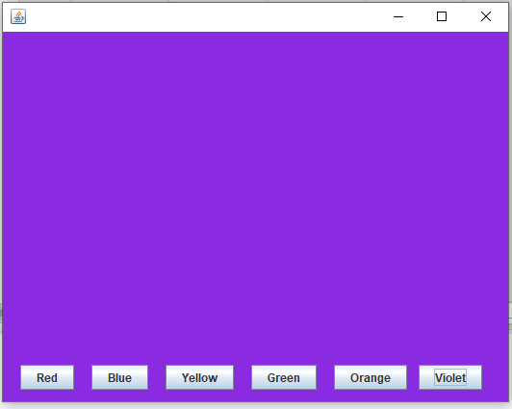

The background color will change once the buttons are clicked.

1. START WITH A NEW ANT PROJECT and add a project name.

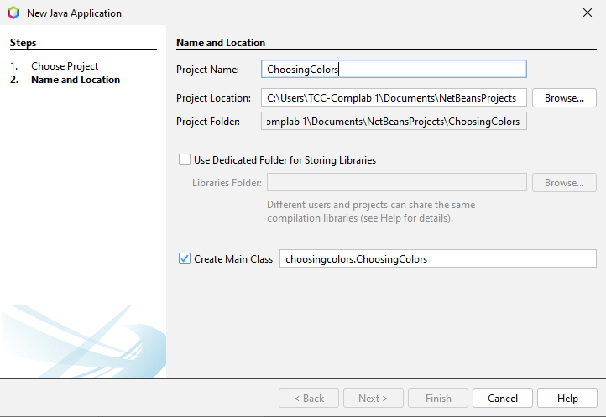Note: Project name should start with CAPITAL LETTERS and NO SPACES BETWEEN WORDS.

1. 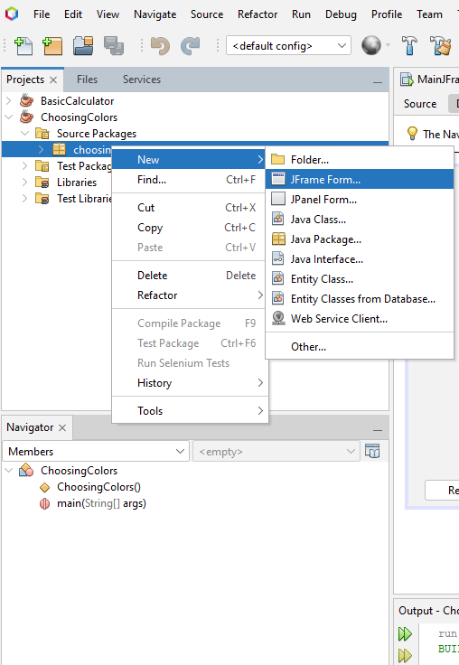Next is to create a new JFrame From. Just give it a name MainJFrame.

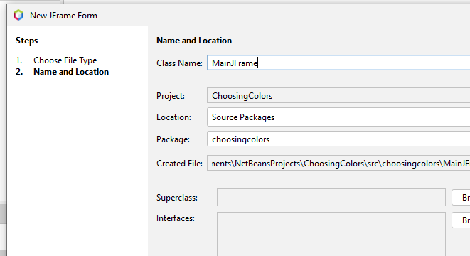

1. Double click on MainJFrame.java on projects panel on the left to view its design. Get a Panel from the Palette and drag it inside the JFrame form and adjust its size to cover the entire width and height of the said form.



1. Add necessary buttons and click on each button and proceed to their properties to change their texts as seen below:

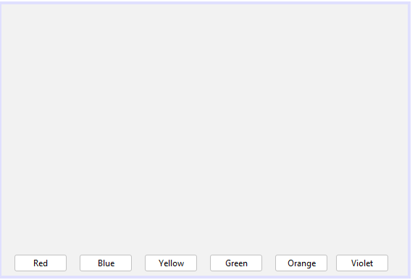

1. After the layout, create a new object for your MainJFrame inside your main class. In my case, it’s ChoosingColors.java

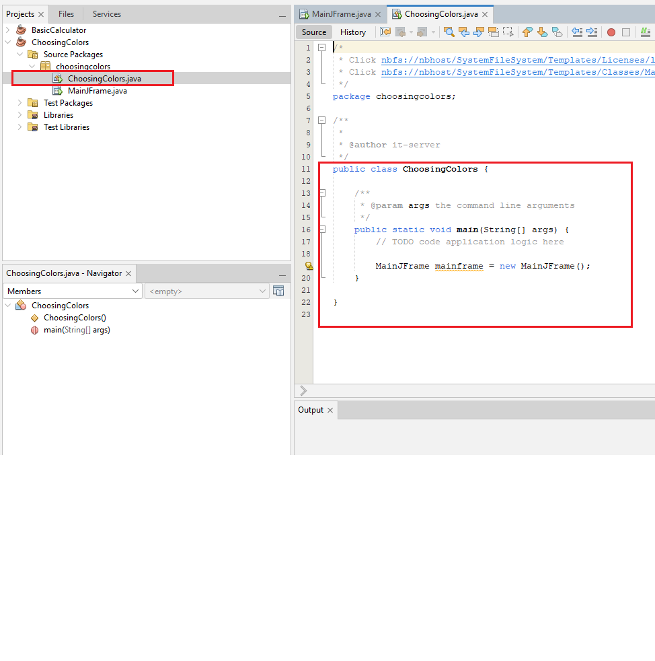

add the code below inside your main class.

MainJFrame mainframe = new MainJFrame();

Write the following source codes for each button.